**Dell PowerEdge R640, FC640s Blade Servers & FX2 Enclosures**

**Overview and Cabling**

*John McFarland December 2017*

Table of Contents:

Dell PowerEdge R640 Product Overview ………………………………….……….2

Dell PowerEdge FC640 Product Overview …………………………………………2

Dell PowerEdge FX2 Enclosure Product Overview ………………………………..3

Dell PowerEdge FX2 Enclosure Cabling & Connecting……………………………4

Dell PowerEdge FX2 Enclosure Cabling Diagrams………………...………………5

Dell Support and contact information……………………………………….………..6

Videos: FX2 Unbox and Rack, CMC Initial Setup………………….……………….6

**Platform Overview** - [**Dell PowerEdge R640**](http://topics-cdn.dell.com/pdf/poweredge-r640_reference%20guide2_en-us.pdf): (1U rack mounted server)

**For all practical purposes this is the HPDL360 Gen10 equivalent:**





Memory slots: 24 (12 w/single proc).

Drives: 8 x 2.5 inch hard drives or 4 x 3.5 inch hard drives on the front panel, or 10 x 2.5 inch hard drives on the front panel with optional support for 2 X 2.5 inch hard drives on the back panel

NICs: Four RJ-45 ports that support 10, 100 and 1000 Mbps

PCIe slots: 3

**Platform Overview** – [**Dell PowerEdge FC640s**](http://i.dell.com/sites/doccontent/shared-content/data-sheets/en/Documents/PowerEdge-FC640-Spec-Sheet.pdf) (half-height blade server)

**For all practical purposes this is the HPE BL460 Gen10 equivalent:**

Drives: 2 x 2.5 hard drives

Memory: 16 DIMM slots

NICs: Network daughter card options 2 x 10GE + 2 x 1GE, 4 x 10GE

Mezzanine/PCI: 2 slots FX2 based.

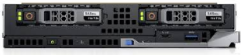

**Platform Overview** – [**Dell PowerEdge FX2 Enclosure**](http://i.dell.com/sites/doccontent/corporate/secure/en/Documents/Dell_PowerEdge_FX2_Spec_Sheet.pdf) 2U blade enclosure (up to 4 blade servers in LM Captiva config)

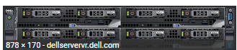

Up to 8 PCI slots – shown w/ Ethernet switch mods & 1600W P/S (ours will have 2 x 2000W w/ **C19/C20 power cords**)

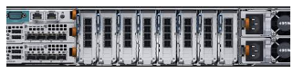

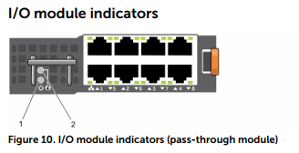

***Dell Verbiage:***

**CMC**: Chassis Management Controller (HPE’s Onboard Administrator equivalent)

**iDRAC** port (iLO port equivalent)

FX2 Cabling & Connecting

**Note:** The **CMC Module** is the Onboard Administrator equivalent. This management access/port/s are shared connections for the blade server management (iLO/IDRAC) connections. Please reference [CMC - iDRAC Config](https://itcomposites.lmig.com/Sites/Midrange/InfrastructureLogistics/ExternalDocuments/Dell/CMC%20-%20iDRAC%20Configuration%20Dell%20FX2.docx) doc for CMC access and configuration details.

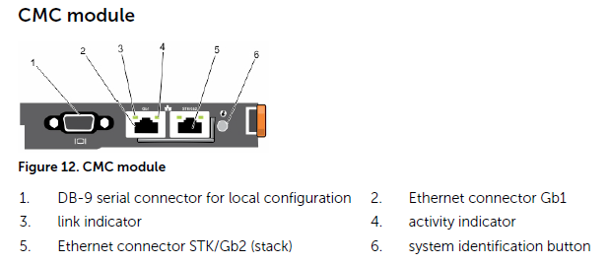

**FX2 Cabling in a 4-server configuration**

Server slot (sled) position – front of enclosure:

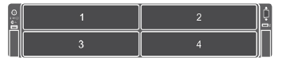

Network – NIC pass through ports to server – teaming uses corresponding mod ports Server 1: A1-port1 & A2-port1, Server 2: A1-port3 & A2-port3 (red to red, blue to blue)

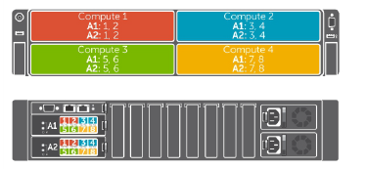

PCIe (HBAs) Note the order: 7&8, 3&4, 5&6, 1&2

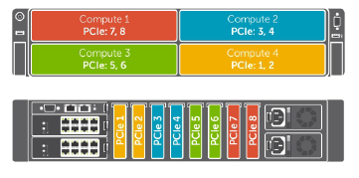

**Note:** Standard cabling for LM data centers including MTA and initial Captiva 2 & 4 server configs should follow this example:

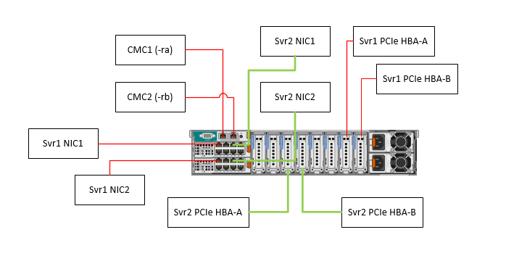

**Dell Support:**

To open a Dell service request call **855-305-9057**

Reference the 8 digit alphanumeric **Service Tag #** on the server/enclosure.

Reference the [Dell ProSupport Plus](http://www.dell.com/downloads/global/services/ProSupport-Plus-technical-support-numbers-1.pdf) technical support for additional info.

**Dell technicial contacts:**

Joe Ferri: [joe.ferri@dell.com](mailto:joe.ferri@dell.com) 207.570.8679

Matt Steinberg: [Matt.Steinberg@dell.com](mailto:Matt.Steinberg@dell.com) 781.444.4308

John Jones: [John.Jones@dell.com](mailto:John.Jones@dell.com) 512.513.9405

**Videos:**

FX2 Unboxing & Racking video: <https://www.youtube.com/watch?v=rAu_kvODGck>

CMC Initial configuration video: <https://www.youtube.com/watch?v=L2RoK2hXA2o>